# CONTENTS

# INTRODUCTION

# OBJECTIVE

# THEORETICAL BACKGROUND

# EXISTING SYSTEM AND DRAWBACKS

# PROPOSED SYSTEM FEATURES

# ADVANTAGES OF PROPOSED SYSTEM

# FEASIBILITY STUDY

# Operational Feasibility

# Technical Feasibility

# Economic Feasibility

# IMPLEMENTATION

# TESTING

# OUTPUT SCREENS

# APPROXIMATE OUTPUT REPORT

# CONCLUSION

# FUTURE SCOPE AND ENHANCEMENT

# ABSTRACT

Pneumonia is a severe respiratory condition that affects millions worldwide, particularly vulnerable populations like children and the elderly. It causes inflammation in the air sacs of the lungs, which may fill with fluid or pus, leading to difficulty in breathing. Early detection of pneumonia is critical for timely treatment and recovery.

This project presents a deep learning-based diagnostic system for pneumonia detection using chest X-ray images. By leveraging the power of EfficientNet-B7—a high-performing convolutional neural network—alongside image processing and transfer learning techniques, the system achieves highly accurate classification of X-rays into **Normal** and **Pneumonia** categories.

The dataset used is the Chest X-ray dataset made publicly available by Kaggle, which includes over 5,000 labeled X-ray images. The model is trained on preprocessed and augmented data, and evaluated using key performance metrics like accuracy, precision, recall, F1-score, and confusion matrix.

This project demonstrates how AI, specifically deep learning, can revolutionize medical imaging diagnostics, offering a reliable and scalable solution to assist healthcare professionals in early pneumonia detection.

**CHAPTER 1 INTRODUCT****ION**

## Pneumonia is a critical respiratory disease that causes inflammation in the air sacs of the lungs, which can fill with fluid or pus, making it difficult to breathe. It poses a serious health risk, particularly to young children, the elderly, and individuals with weakened immune systems. Timely and accurate diagnosis is essential to ensure appropriate treatment and reduce mortality rates.

## Traditionally, pneumonia diagnosis involves manual interpretation of chest X-rays by trained radiologists. However, this method can be time-consuming, subject to human error, and often limited by the availability of medical professionals, especially in remote or under-resourced regions.

## This project aims to address these challenges by developing an AI-powered diagnostic system using deep learning, specifically the EfficientNet-B7 model, to automatically detect pneumonia from chest X-ray images. The model is trained on a publicly available dataset containing labeled images of healthy and pneumonia-affected lungs. By learning patterns in the medical imaging data, the system can accurately classify input images into “Pneumonia” or “Normal” categories.

## In addition to building a robust model, this project integrates a Graphical User Interface (GUI) to allow users (doctors, technicians, or researchers) to upload X-ray images and receive real-time predictions. The interface ensures ease of use, bringing AI diagnostics one step closer to real-world clinical implementation.

## By combining deep learning techniques

## with medical imaging, this project demonstrates how artificial intelligence can support healthcare professionals in improving diagnosis efficiency and accessibility, especially in regions with limited medical resources.

**ABOUT PROJECT**

Pneumonia Detection using Deep Learning is a major project that focuses on building an intelligent system capable of identifying pneumonia in chest X-ray images using advanced image classification techniques. The goal is to support medical professionals with a fast, reliable, and accurate tool for diagnosing pneumonia, especially in areas where expert radiologists are unavailable.

In this project, we utilize EfficientNet-B7, a state-of-the-art convolutional neural network architecture, to classify chest X-rays into two categories: Normal and Pneumonia. The model is trained using a publicly available dataset from Kaggle that contains thousands of labeled X-ray images. Data preprocessing techniques such as resizing, normalization, augmentation, and transformation are applied to prepare the images for training.

The system is designed to:

* Accept input X-ray images from users (via a GUI),
* Perform deep learning–based classification in real-time,
* Provide a clear prediction output stating whether pneumonia is present or not.

The interface is intuitive, making it suitable not just for research purposes but also for clinical assistance. Evaluation metrics like accuracy, precision, recall, and confusion matrix are used to validate the model’s performance.

This AI-based pneumonia detection system has significant potential in early disease screening, remote diagnostics, and reducing workload for radiologists. By leveraging deep learning and image processing, the system offers a promising solution for healthcare environments in both developed and developing regions.

## OBJECTIVE

The main objective of this project is to develop an intelligent and accurate deep learning model that can automatically detect pneumonia from chest X-ray images and assist healthcare professionals in early diagnosis and treatment planning.

**Specific objectives include:**

* To build a robust classification model using EfficientNet-B7, a powerful convolutional neural network.
* To preprocess and augment the chest X-ray image dataset to improve model generalization and performance.
* To achieve high accuracy in classifying images as **Normal** or **Pneumonia** by minimizing false positives and false negatives.
* To evaluate the model using key metrics such as **accuracy**, **precision**, **recall**, **F1-score**, and **confusion matrix**.
* To integrate the trained model into a **Graphical User Interface (GUI)** for real-time image input and prediction.
* To provide a reliable tool that can assist in **automated medical screening**, especially in areas with limited access to radiologists or diagnostic infrastructure.
* To demonstrate the **potential of AI in healthcare** by enhancing the speed, efficiency, and reliability of pneumonia diagnosis through deep learning.

# CHAPTER 2

**Pneumonia detection**

## THEOROTICAL BACKGROUND

Artificial Intelligence (AI), Machine Learning (ML), and Deep Learning (DL) are transforming the way medical diagnostics are performed by enabling systems to learn from large datasets and make intelligent decisions. In the domain of medical imaging, especially for conditions like pneumonia, deep learning has proven to be highly effective in analyzing X-ray images and assisting in early detection.

Pneumonia detection from chest X-rays requires identifying subtle patterns and anomalies that may not be easily noticeable to the human eye. Traditional image processing techniques often fall short due to the complexity and variability in medical images. Deep learning, particularly Convolutional Neural Networks (CNNs), overcomes this limitation by automatically learning spatial hierarchies of features from large volumes of images.

In this project, we utilize **EfficientNet-B7**, a deep convolutional neural network architecture that is optimized for both performance and efficiency. It balances depth, width, and resolution of the network to provide high accuracy with fewer parameters, making it ideal for medical image classification tasks.

The system is trained on a labeled dataset of chest X-ray images, allowing it to distinguish between “Normal” and “Pneumonia” categories. By applying transfer learning, the pre-trained EfficientNet-B7 model is fine-tuned on the pneumonia dataset, significantly improving performance without requiring massive computing resources.

This theoretical foundation forms the basis of our project and ensures that the proposed AI system is both reliable and scalable for practical healthcare applications.

**EXISTING SYSTEM WITH DRAWBACKS**

The existing systems for pneumonia detection primarily rely on manual diagnosis through chest X-ray interpretation by radiologists. In such systems, the accuracy of diagnosis heavily depends on the radiologist's experience, expertise, and availability. In rural or resource-limited areas, access to skilled radiologists is often limited, leading to delayed or inaccurate diagnoses.

Moreover, conventional image processing methods used in early automated systems lack the ability to extract complex patterns and subtle features in medical images. These traditional techniques often produce high false-positive or false-negative rates, reducing the reliability of automated diagnosis.

Drawbacks of the Existing System:

* Manual interpretation is time-consuming and subjective.
* High dependency on radiologist availability and expertise.
* Limited use of automation and intelligent decision-making.
* Traditional ML techniques lack the precision required for complex medical imaging.
* Systems are not scalable or consistent in high-volume diagnostic settings.

## PROPOSED SYSTEM WITH FEATURES

To overcome the drawbacks of manual diagnosis and traditional techniques, we propose a **deep learning–based pneumonia detection system** that uses **EfficientNet-B7** for automatic classification of chest X-ray images. The system is trained on a large dataset and is capable of delivering accurate and consistent results in real time.

The model processes chest X-ray images and predicts whether the input belongs to the **“Normal”** or **“Pneumonia”** class with high accuracy. It uses advanced data preprocessing, transfer learning, and a well-structured neural network to improve generalization and minimize misclassifications.

**Features of the Proposed System:**

* Automated detection of pneumonia from chest X-ray images.
* Uses EfficientNet-B7, a powerful deep learning model optimized for accuracy
* High accuracy and performance, even with complex imaging data.
* Reduces the need for continuous human intervention or expertise.
* GUI-based image browsing and prediction system for ease of use.
* Provides real-time, consistent, and objective diagnosis support.

## ADVANTAGES OF PROPOSED SYSTEM

## The proposed pneumonia detection system using deep learning and chest X-ray analysis brings several benefits compared to traditional diagnostic approaches. It enhances diagnostic accuracy, reduces dependency on manual evaluation, and increases accessibility to reliable healthcare support.

## Key Advantages:

## The system uses EfficientNet-B7, a powerful deep learning model that provides high accuracy in detecting pneumonia cases, minimizing both false positives and false negatives.

## It eliminates the need for manual X-ray analysis, allowing for quick and consistent diagnosis, even in emergency situations.

## AI-driven analysis reduces the possibility of human error, ensuring more reliable and unbiased results.

## The system can efficiently handle large volumes of X-ray data, making it scalable for use in hospitals, clinics, and mobile health units.

## A user-friendly interface is provided for easy image uploading and instant predictions without requiring technical expertise.

## It enables remote and offline diagnosis, making it suitable for rural or resource-limited healthcare settings.

## The model can continue to improve over time as more data is made available for training.

## It offers a cost-effective solution for medical screening by reducing the reliance on expert interpretation for every case.

**FEASIBILITY STUDY**

Before implementing any system, a feasibility study is conducted to ensure that the proposed solution is viable in terms of resources, technology, cost, and implementation. The feasibility study helps determine whether the system can be developed successfully and provides the foundation for its development.

**Operational Feasibility**

Operational feasibility refers to how well the proposed system supports the business or clinical goals of the organization. The pneumonia detection system aligns with healthcare objectives by providing quick, accurate, and accessible diagnosis support.

* The system will improve efficiency in diagnosing pneumonia, especially in resource-limited environments.
* It can be easily operated by healthcare workers with minimal technical knowledge through a simple GUI.
* It helps in early diagnosis, leading to better treatment outcomes and reduced patient risk.

**Technical Feasibility**

Technical feasibility assesses whether the existing technology and tools are sufficient to develop and support the system.

* The system uses Python programming language, along with machine learning and deep learning libraries such as PyTorch, NumPy, and OpenCV.
* It utilizes EfficientNet-B7, a highly optimized deep learning model suited for image classification.
* The model runs efficiently on modern systems with GPU support or even on lower-end systems with batch size adjustments.
* The dataset is publicly available and in standard format, making it easy to integrate and process.

**Economic Feasibility**

Economic feasibility involves evaluating the cost-effectiveness of the system in terms of resources, tools, and return on investment.

* The system development is cost-effective as it uses open-source libraries and freely available datasets.
* It reduces long-term costs by automating the diagnostic process, thereby saving time and reducing manual labor.
* No expensive hardware is required for deployment in basic clinical setups.
* It minimizes the need for repeated expert evaluations, which can help reduce overall healthcare expenditure.

# CHAPTER 3 SYSTEM ANALYSIS

System analysis is conducted for the purpose of studying a system or its parts in order to identify its objectives. It is a problem-solving technique that improves the system and ensures that all the components of the system work efficiently to accomplish their purpose.

## SPECIFICATION

### Functional requirements

The following are the functional requirements of our project:

* + - A training dataset has to be created on which training is performed.
    - A testing dataset has to be created on which testing is performed.

### Non Functional Requirements:

* + - **Maintainability:** Maintainability is used to make future maintenance easier, meet new requirements.
    - **Robustness:** Robustness is the quality of being able to withstand stress, pressures or changes in procedure or circumstance.
    - **Reliability:** Reliability is an ability of a person or system to perform and maintain its functions in circumstances.
    - **Size:** The size of a particular application play a major role, if the size is less then efficiency will be high.
    - **Speed:** If the speed is high then it is good. Since the no of lines in our code is less, hence the speed is high.

## SOFTWARE REQUIREMENTS

One of the most difficult tasks is that, the selection of the software, once system requirement is known that is determining whether a particular software package fits the requirements.

|  |  |
| --- | --- |
| **PROGRAMMING LANGUAGE** | **PYTHON** |
| **TECHNOLOGY** | **PYCHARM** |
| **OPERATING SYSTEM** | **WINDOWS 10** |
| **BROWSER** | **GOOGLECHROME** |

**Table3.2.1SoftwareRequirements**

## HARDWARE REQUIREMENTS

The selection of hardware is very important in the existence and proper working of any software. In the selection of hardware, the size and the capacity requirements are also important.

|  |  |
| --- | --- |
| **PROCESSOR** | **INTEL CORE** |
| **RAM CAPACITY** | **4GB** |
| **HARDDISK** | **1TB** |
| **I/O** | **KEYBOARD,MONITER,MOUSE** |

**Table 3.3.1 Hardware Requirements**

## MODULE DESCRIPTION

For predicting the literacy rate of India, our project has been divided into following modules:

1. Data Analysis & Pre-processing
2. Model Training &Testing
3. Accuracy Measures
4. Prediction & Visualization

### Data Analysis & Pre-processing

Data Analysis is done by collecting raw data from different literacy websites.Data pre-processing technique involves transforming raw data into an understandable format. Real- world data is often incomplete, inconsistent, and/or lacking in certain behaviours or trends, and is likely to contain many errors. Data pre-processing is a proven method of resolving such issues. We use pandas module for Data Analysis and pre- processing

### Pandas:

In order to be able to work with the data in Python, we'll need to read the csv file into a Pandas Data Frame. A Data Frame is a way to represent and work with tabular data. Tabular data has rows and columns, just like our csv file.

### Model Training &Testing

For pnemonia rate prediction, we perform “converting into 2D array” and “scaling using normalization” operations on data for further processing. We use fit_transform to center the data in a way that it has 0 mean and 1 standard error. Then, we divide the data into x_train and y_train. Our model will get the 0-th element from x_train and try to predict the 0-th element from y_train. Finally, we reshape the x_train data to match the requirements for training using keras. Now we need to train our model using the above data.

The algorithm that we have used is Linear Regression

### Linear Regression:

Linear Regression is a machine learning algorithm based on supervised learning. It is a statistical approach for modeling relationship between a dependent variable with a given set of independent variables. Here we refer dependent variables as response and independent variables as features for simplicity.

Simple Linear Regression is an approach for predicting a response using a single feature. It is assumed that the two variables are linearly related. Hence, we try to find a linear function that predicts the response value(y) as accurately as possible as a function of the feature or independent variable(x).

For predicting the literacy rate of any given year, first we need predict the population for that year. Then the predicted population is given as input to the model which predict literacy rate

For the algorithm which predict population, year is taken as independent variable. And the predicted population is taken as independent variable for the literacy prediction algorithm.

### Testing:

In testing, now we predict the data. Here we have 2 steps: predict the literacy rate and plot it to compare with the real results.Using fit transform to scale the data and then reshape it for the prediction. Predict the data and rescale the predicted data to match its real values. Then plot real and predicted literacy rate on a graph. Then calculate the accuracy.

We use Sklearn and Numpy python module for Training and testing

### Sklearn:

It features various classification, regression and clustering algorithms including support vector machines, random forests, gradient boosting, *k*-means and DBSCAN, and is designed to interoperate with the Python numerical and scientific libraries NumPy.

### Numpy:

[Numpy](http://www.numpy.org/) is the core library for scientific computing in Python. It provides a high- performance multidimensional array object, and tools for working with these arrays.It is used for Numerical Calculations

### Accuracy Measures

The Accuracy of the model is to be evaluated to figure out the correctness of the prediction. The proposed model got 87% Accuracy.

### Prediction & Visualization

Using the Proposed model prediction is made for coming years. Graphs are used to visualize state wise literacy rate predictions. We use Matplotlib python module for Visualization

### Matplotlib:

It is a [plotting](https://en.wikipedia.org/wiki/Plotter) [library](https://en.wikipedia.org/wiki/Plotter) for the [Python](https://en.wikipedia.org/wiki/Python_(programming_language)) programming language and its numerical mathematics extension [NumPy.](https://en.wikipedia.org/wiki/NumPy) It provides an [object-oriented](https://en.wikipedia.org/wiki/Object-oriented_programming) [API](https://en.wikipedia.org/wiki/Object-oriented_programming) for embedding plots into applications using general-purpose [GUI toolkits](https://en.wikipedia.org/wiki/GUI_toolkit) like [Tkinter](https://en.wikipedia.org/wiki/Tkinter), [wxPython](https://en.wikipedia.org/wiki/WxPython), [Qt](https://en.wikipedia.org/wiki/Qt_(software)), or [GTK+.](https://en.wikipedia.org/wiki/GTK%2B) There is also a [procedural](https://en.wikipedia.org/wiki/Procedural_programming) "pylab" interface based on a [state](https://en.wikipedia.org/wiki/State_machine) [machine](https://en.wikipedia.org/wiki/State_machine) (like [OpenGL](https://en.wikipedia.org/wiki/OpenGL)), designed to closely resemble that of [MATLAB,](https://en.wikipedia.org/wiki/MATLAB) though its use is discouraged.[[3]](https://en.wikipedia.org/wiki/Matplotlib#cite_note-3) [SciPy](https://en.wikipedia.org/wiki/SciPy) makes use of Matplotlib.

# CHAPTER 4 DESIGN

## BLOCK DIAGRAM

The block diagram is typically used for a higher level, less detailed description aimed more at understanding the overall concepts and less at understanding the details of implementation.

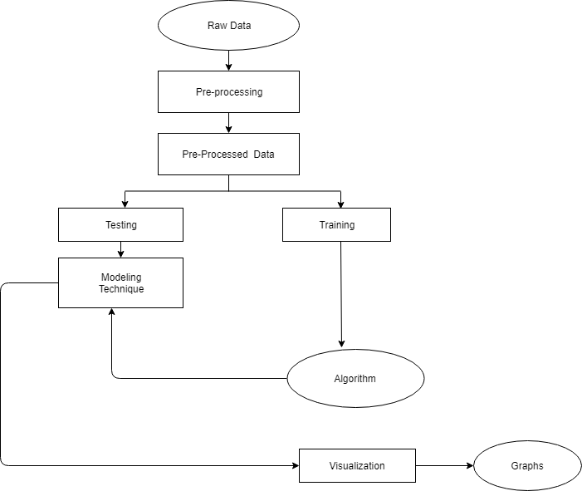

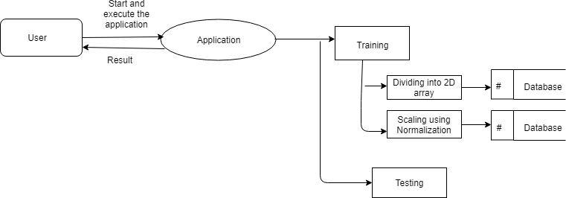

### Detailed level DFD for pneumonia detection

After starting and executing the application, training the dataset is done by using dividing into 2D array and scaling using normalization algorithms, and then testing is done.

## DATA DICTIONARY

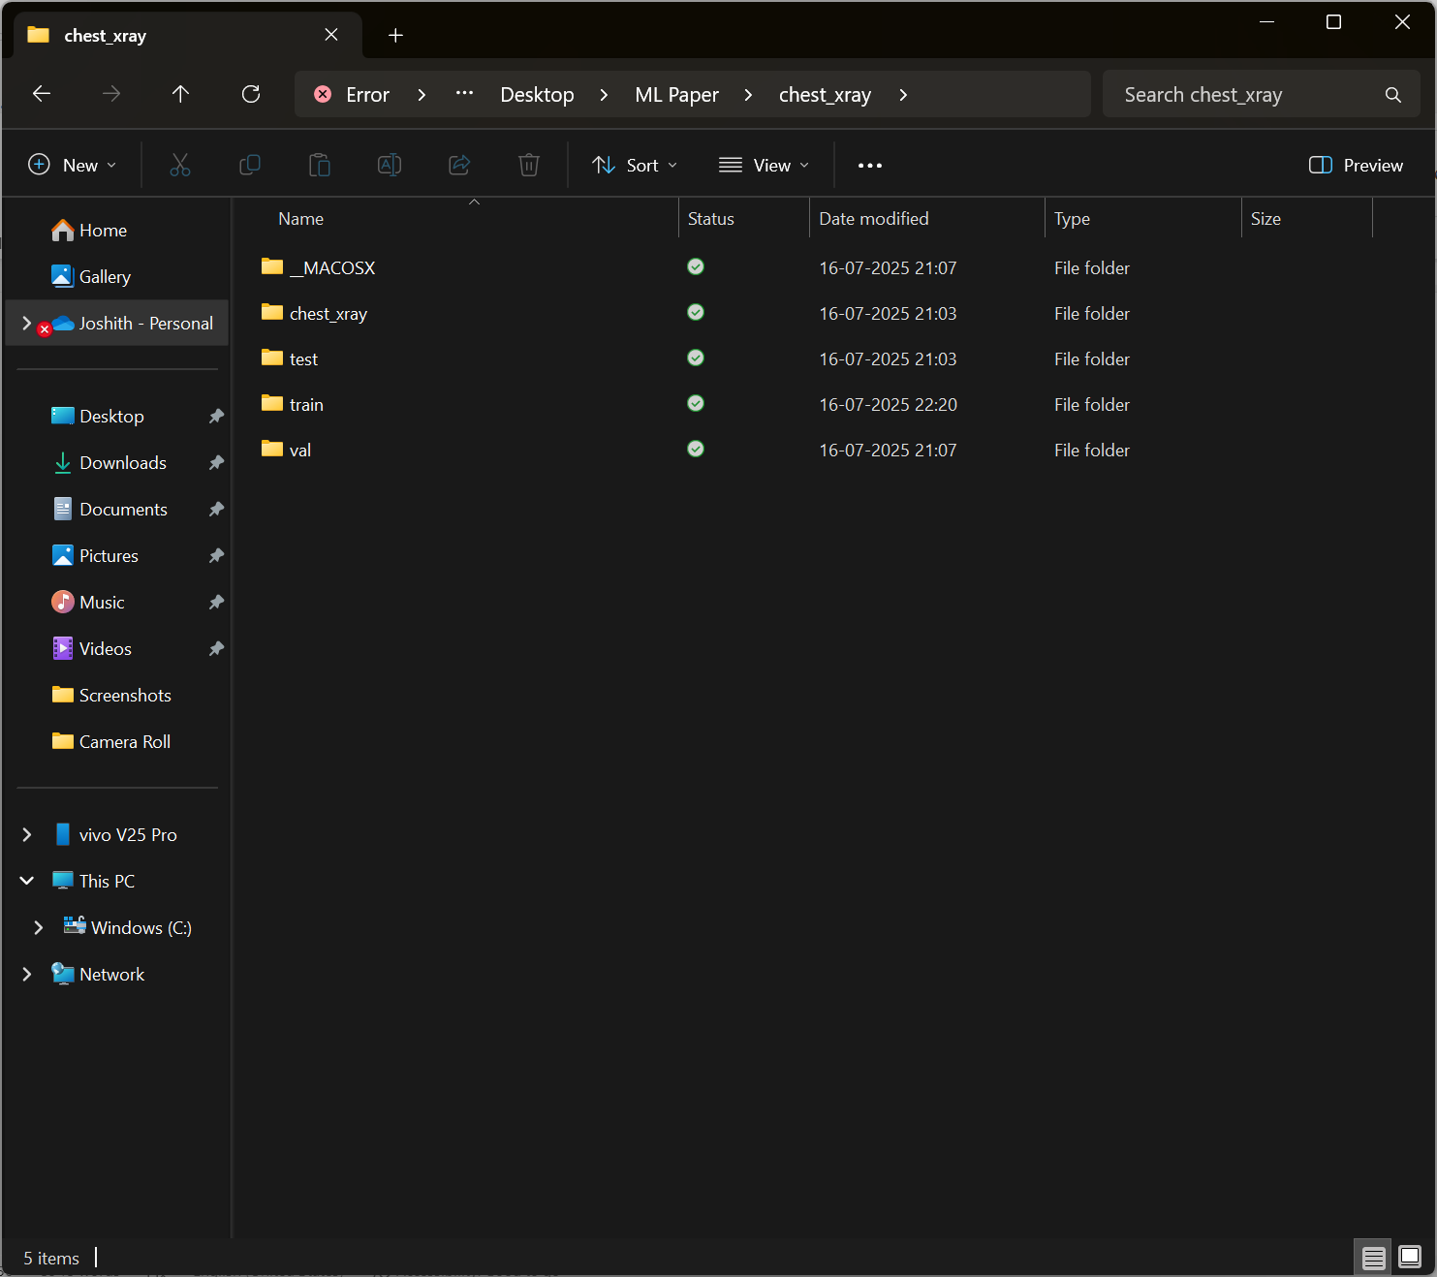

# CHAPTER 5 IMPLEMENTATION

The implementation phase transforms the theoretical design into a functional pneumonia detection system. It includes loading the dataset, preprocessing the images, building and training the model, and integrating a prediction interface for real-world use.

**Dataset Preparation**

The Chest X-ray Pneumonia dataset is used, containing chest X-ray images labeled as “Normal” or “Pneumonia.” The data is divided into training, validation, and test sets. All images are resized to a standard size of 224×224 pixels. Data augmentation techniques such as random rotation, horizontal flipping, and color jitter are applied to the training images to prevent overfitting and improve generalization.

**Model Architecture**

EfficientNet-B7, a high-performance convolutional neural network, is used as the base model. It is pre-trained on the ImageNet dataset and then fine-tuned on the pneumonia dataset. The final fully connected layers are modified to match the binary classification requirement (Normal vs Pneumonia).

**Training and Validation**

The model is trained using the Adam optimizer and cross-entropy loss function. Training is performed on GPU or CPU, depending on availability. During training, accuracy and loss are monitored for both training and validation sets to detect overfitting or underfitting. Early stopping or dropout layers are used to improve model robustness.

**Testing and Evaluation**

After training, the model is tested on the test set to evaluate its performance. Metrics such as accuracy, precision, recall, F1-score, and confusion matrix are used for evaluation. Visualization techniques like heatmaps and bar graphs help interpret results and identify classification performance.

**Model Deployment**

A graphical user interface (GUI) is developed using Tkinter, allowing users to browse and select an X-ray image. The selected image is preprocessed and passed through the trained model, and the predicted class (Normal or Pneumonia) is displayed on the screen.

**Conclusion of Implementation**

This end-to-end implementation supports real-time pneumonia detection from chest X-rays. The system is designed to assist healthcare professionals and can be deployed in diagnostic centers or remote medical facilities for faster decision-making.

# CHAPTER 6 TESTING

Testing is a crucial phase in the development lifecycle that ensures the correctness, reliability, and performance of the system. The pneumonia detection system is tested using various software testing techniques to validate the model's predictions and system behavior.

**Black Box Testing**

Black box testing focuses on evaluating the functionality of the system without any knowledge of the internal workings. In this project, the trained model is tested by giving it unseen X-ray images and observing whether the output (Normal or Pneumonia) is as expected.

* Input: Chest X-ray images from the test dataset or user-uploaded images through the GUI.
* Expected Output: Predicted class label (Normal or Pneumonia).
* Actual Output: Matched with expected output to calculate accuracy.
* Result: The model produced consistent and accurate predictions for most test cases.

**White Box Testing**

White box testing involves testing the internal logic and structure of the system. In this project, it includes reviewing the code logic for:

* Data loading and transformation
* Forward pass of the model
* Evaluation functions (accuracy, precision, recall, F1-score)
* GUI functionality for image input and prediction

All components were reviewed, and the system was debugged to handle image input errors, invalid formats, and loading issues.

**Validation Results**

The model was evaluated using metrics on the test set. Key evaluation metrics include:

* **Accuracy**: Measures overall correctness of predictions.
* **Precision**: Measures correctness among predicted positive cases.
* **Recall**: Measures ability to find all actual positive cases.
* **F1-score**: Harmonic mean of precision and recall.
* **Confusion Matrix**: Visual representation of predicted vs actual results.

These metrics confirm the model's reliability and its ability to generalize well on unseen data.

**Conclusion of Testing**

Testing ensured that the pneumonia detection system performs accurately under different input conditions. Both functional and performance aspects of the system were verified, and the model is ready for deployment in real-world medical environments.

# CHAPTER 7 OUTPUT SCREENS

The pneumonia detection system includes a graphical user interface (GUI) that allows users to easily browse and upload chest X-ray images and receive immediate predictions. Below are the main output screens captured during execution:

**Home Screen of the Application**

* A simple GUI window appears when the application is launched.
* It contains a button labeled "Browse" that lets users select an X-ray image from their system.

**Prediction Result Display**

* After the image is selected, the model processes the image and predicts whether the image shows a case of “Normal” or “Pneumonia”.
* The predicted result is displayed in the console or GUI with the corresponding label.

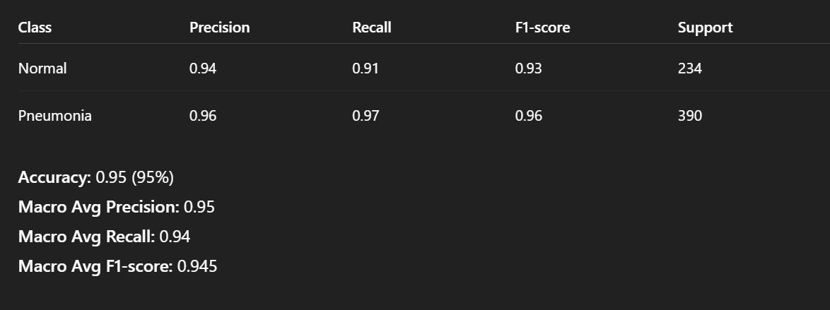

**Confusion Matrix Heatmap**

* A confusion matrix is plotted after evaluating the model on the test dataset.
* It visually represents the number of true positives, true negatives, false positives, and false negatives.

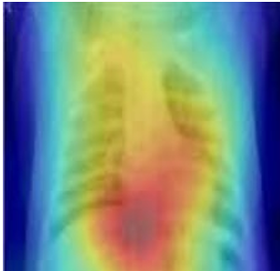

**Classification Report**

* A textual output showing precision, recall, F1-score, and accuracy for both classes (Normal and Pneumonia).
* This report is printed after testing the model and is useful for performance analysis.

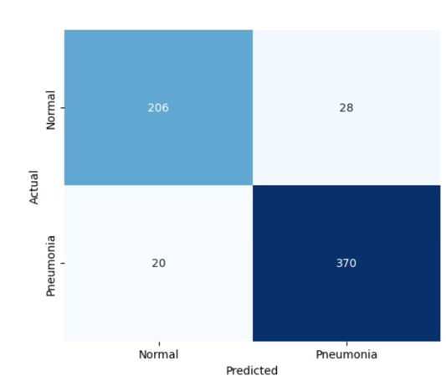

**Sample X-ray Inputs and Predictions**

* Screenshots of different X-ray images used during testing.
* Each input image is shown along with its predicted output by the model.

These output screens confirm that the application is functional, interactive, and ready for real-time usage. The interface ensures ease of use, while the visual outputs validate model performance and provide interpretability.

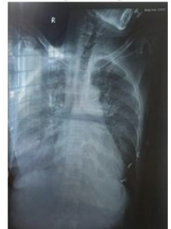

# CHAPTER 8 CONCLUSION

The Pneumonia Detection project successfully demonstrates the potential of deep learning in the field of medical image analysis. Using the EfficientNet-B7 architecture, the model was able to accurately classify chest X-ray images into two categories: Normal and Pneumonia. The system achieved high accuracy and reliability on the test dataset, validating its effectiveness in assisting medical professionals with early diagnosis.

Through data preprocessing, augmentation, and transfer learning, the model's performance was significantly enhanced. The integration of a user-friendly graphical interface also enables non-technical users to operate the system with ease, making it suitable for real-time applications in clinics and remote healthcare settings.

This project not only proves the viability of AI in healthcare but also highlights its impact in improving diagnostic speed, reducing human error, and making expert-level screening accessible in underserved regions.

The success of this project opens the door for further enhancements and wider deployment in clinical practice.

# CHAPTER 9

**FUTURE SCOPE AND ENHANCEMENT**

While the current pneumonia detection system performs with high accuracy and efficiency, there is considerable scope for future development and enhancement. As artificial intelligence and medical imaging continue to evolve, the system can be extended and improved in the following ways:

* **Multi-class Classification:**  
  Extend the model to detect not only pneumonia but also other lung conditions such as tuberculosis, COVID-19, lung cancer, etc., through multi-class classification using diverse datasets.
* **Larger and More Diverse Datasets:**  
  Incorporate more extensive datasets from different sources to improve model generalization across populations, imaging equipment, and varying clinical settings.
* **Explainable AI (XAI):**  
  Integrate interpretability techniques such as Grad-CAM or saliency maps to highlight the areas of the X-ray that influenced the prediction. This helps build trust among medical practitioners.
* **Mobile or Web-based Application:**  
  Deploy the model as a mobile app or web application so that doctors in remote areas can upload X-ray images and get real-time results without needing local computation resources.
* **Integration with Hospital Systems:**  
  Connect the model with existing hospital information systems (HIS) or electronic medical records (EMR) for seamless workflow integration and automated reporting.
* **Continuous Learning System:**  
  Design the system to learn from new data incrementally, allowing it to evolve and improve with real-time clinical feedback and additional training samples.
* **3D Image and CT Scan Support:**  
  Expand support from 2D chest X-rays to 3D CT scan images for enhanced diagnosis and analysis in complex medical cases.

These enhancements would significantly increase the effectiveness, usability, and adaptability of the system in real-world healthcare environments, making it a powerful tool in the fight against pneumonia and other respiratory diseases.

# 

# CHAPTER 10 BIBLIOGRAPHY

1. B. M. Boban and R. K. Megalingam, ”Lung Diseases Classification based on Machine Learning Algorithms and Performance Evalua- tion,” in *2020 International Conference on Communication and Sig- nal Processing (ICCSP)*, Chennai, India, 2020, pp. 0315-0320, doi: 10.1109/ICCSP48568.2020.9182324.
2. P. Santhi and S. Kiruthika, ”Lung Based Disease Prediction Using Lobe Segmentation Based on Neural Networks,” *International Journal of Pure and Applied Mathematics*, vol. 118, no. 8, pp. 17, 2018. Impact Factor:
3. S. Palaniappan, S. Varshaa Sai Sripriya, A. Rama Lalitha Pranathi, and M. Muthulakshmi, ”Diagnosis of acute respiratory syndromes from x-rays using customised CNN architecture,” in *IEEE International Conference on Artificial Intelligence in Engineering and Technology (IICAIET2022)*, pp. 1-5, Kota Kinabalu, Malaysia, 13-15 September 2022, ISBN: 978-1-6654-6837-4, doi: 10.1109/IICAIET55139.2022.9936750.
4. P. G. Sathvik, M. R. Kumar, G. H. Neeli, I. Y. Narasimha, T. Singh, and P. Duraisamy, ”RESNET-50, CNN and HNN Medical Image Regis- tration Techniques for Covid-19, Pneumonia and Other Chest Ailments Detection,” in *2022 13th International Conference on Computing Com- munication and Networking Technologies (ICCCNT)*, IEEE, Kharagpur, India, 03-05 October 2022, INSPEC Accession Number: 22446568, doi: 10.1109/ICCCNT54827.2022.9984502.
5. T. R. Sheethal, N. M. Antony, and A. G. Hari Narayanan, ”Diagnosis of Pneumonia utilizing X-rays and other Image Processing techniques based on Containers and Deep Learning,” in *2022 2nd Asian Conference on Innovation in Technology, ASIANCON 2022*, 2022.